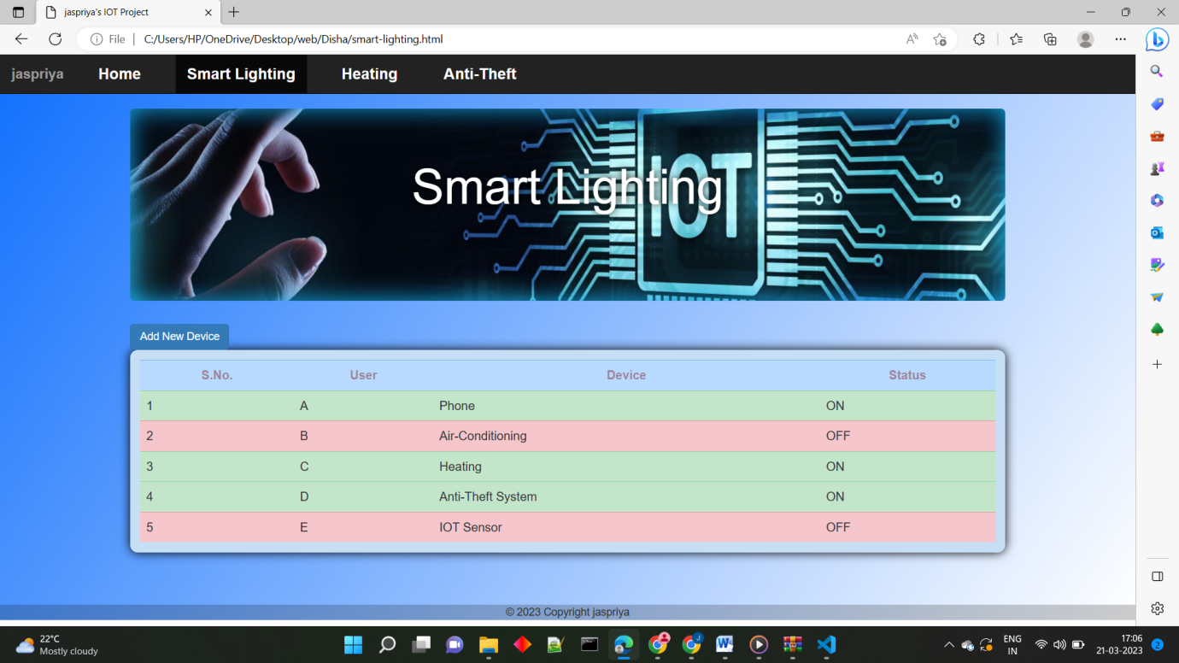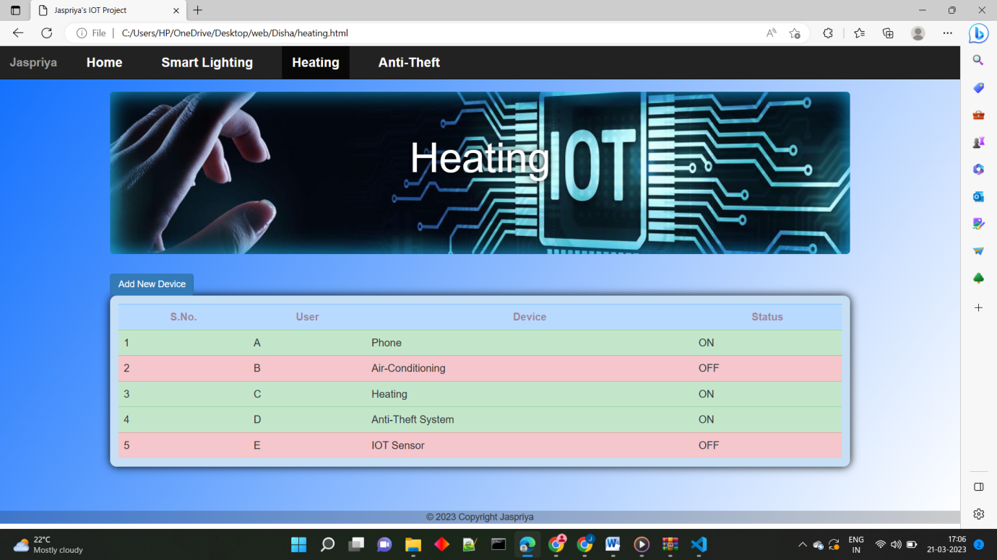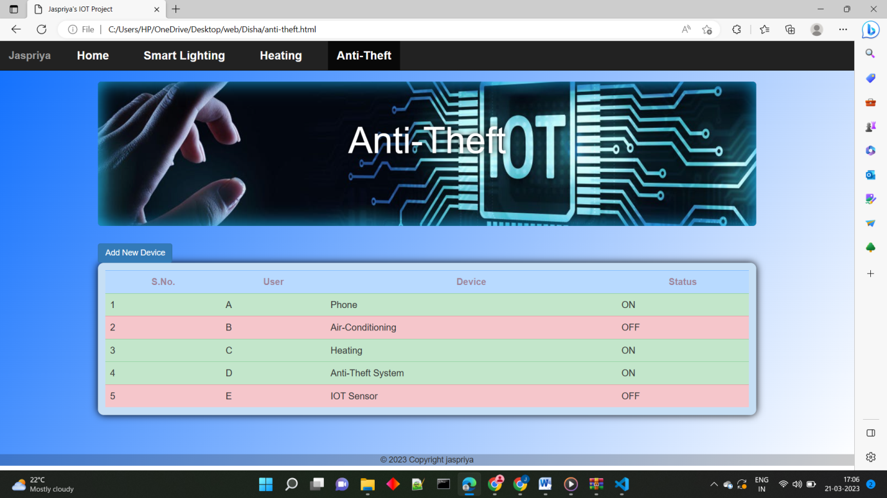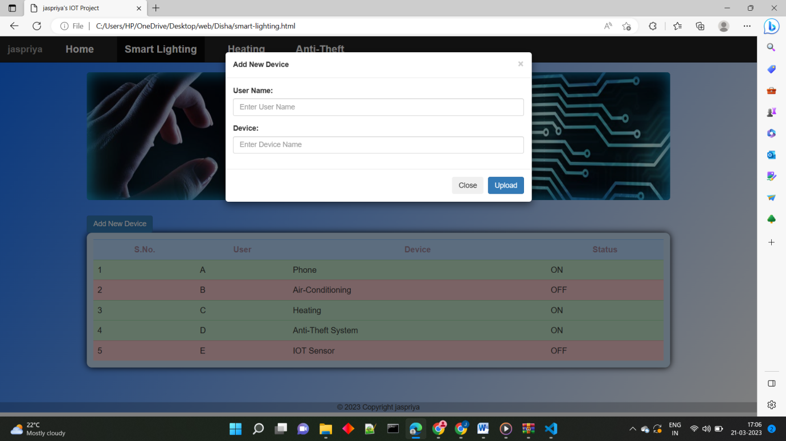

This is a web page written in HTML that displays information about jaspriya's IOT project. This page has a navigation bar at the top with links to the Home, Smart Lighting, Heating, and Anti-Theft pages. The main content of the page revolves around smart lighting and includes a table with information about devices. B. User, Device Name, and Status. There is also a button for adding a new device, which opens a modal window with a form for entering a username and device name. This page uses Bootstrap for styling and jQuery for JavaScript functionality.

This is the front end of the page